AGEING AND SECULAR SOCIAL INVOLVEMENT: EXPLORING THE CONTRIBUTIONS OF RELIGIOUS, CHARACTERISTICS INDIVIDU TO SUBJECTIVE WELLBEING

Rachmah Indawati*, Kuntoro*, Hari Basuki Notobroto*, M. Bagus Qomaruddin**
* Departement of Biostatistics and Population Study, Public Health School, Airlangga University
** Departement of Health Promotion and Behavioral Sciences, Public Health School, Airlangga University

Article Info |  | ABSTRACT
Article history:  Received Jun 12th, 201x  Revised Aug 20th, 201x  Accepted Aug 26th, 201x |  | The social environment can affect the aging individual. Elderly people can feel the possibility of social change in their lives. Elderly people should seek to control social environment and improve well being. The feeling of satisfaction is essential to the health of subjective. Religion and Spirituality can provide a unique perspective on life outcomes. The study to deepen subjective well being by exploring its relationships with religios and spirituality (secular values) and characteristics individu by the graph. Data were obtained from survey. The sample was drawn from the population aged 70 or more years in Surabaya by simple random sampling. The instrument using the Philadelphia geriatric center morale scale (PGCMS) and the self spirituality and religios. Results, the mean of religiosity and spirituality was 3. This showed that most respondents reported being 'low of religiostity and spirituality’ in their lives. The mean PGCMS score was 7.89. The median PGCMS score was 8, 57.4% (139) score PGCSM above the median and 42.6% (103) score PGCSM under the median. Among elderly who were included the high well being category (PGCSM ≥10) was 27.2% and most of elderly 72.7% didn’t have good well being. The elderly people who describe themselves as religious are showed graph constan or stable. The graph of self religious are equal according to characteristics individu (age, men and women, marital status). The elderly who describe themselves as spiritual are likely to report greater or lower perceived well being. Exploring using the graph showed different according to characteristics individu. Elderly who demonstrated subjective well being were more likely to male and not married. Elderly’s perception of spirituality depends on characteristic individuals and experience in which individuals live. The degree of subjective well being that it may be depend on elderly make meaning of life.
Keyword:
Growing old
Subjective well being
Elderly
Religious
Spiritual
Characteristics individu

Copyright © 201x Institute of Advanced Engineering and Science.
All rights reserved.
Corresponding Author:
First Author,
Departement of Biostatistics and Population Study,
Airlangga University,
Kampus C Fakultas Kesehatan Masyarakat Universitas Airlangga, Jl. Mulyorejo Surabaya 60115, Jawa Timur, Indonesia.
Email: rachmah.indawati@gmail.com

- INTRODUCTION
East Java has experienced a demographic transition. East Java is aging at a rapid pace Because fertility declines and adults aged over 65+ at 7:07% of the total population [1]. According the United nations population dividion (2002), Indonesia approximation older people to be Among the highest in the world in the Decades. Based on the general description of the population in East Java showed some facts. Some demographic characteristics is important to look at the phenomenon of the aging process. Socio-economic conditions at the individual level shows the percentage of the total labor force (in the age group 60+) are still lower. This means that most of the older age group is not productive. The percentage of the total workforce in some areas in East Java is still lower than the regional figure (5.07%). Another phenomenon is the level of education shows that the percentage of the population (aged 15+ years) who have never been formal education is still high [3-5].
Indonesia is experiencing rapid economic growth before 1990 [6], it is characterized by the emergence of metropolitan cities in several regions in Indonesia. Based on data from the socio-economic conditions in East Java, East Java family faced a very serious level. Of the total population of 37,879,713 inhabitants in East Java, there are poor families amounting to 1,464,233 families and 53.45% are vulnerable families [3-5].
What about the elderly? Research is unveiling the elderly in several regions in Indonesia. It is said that the elderly are economically less got a chance compared to the average young person [7]. Thus economic conditions will lead to other problems. Based on data showing that serious social problems afflict the elderly is an act of violence that occur in some areas in East Java and the amount is very varied with a range of 0-171 cases [3].
Life expectancy is increasing in the region, there will be the aging of the population [8]. Life expectancy at birth in East Java continues to increase and has reached the age of 70 years. Some areas show a higher life expectancy than the figure in East Java in 2010 which is above 70 years. Conditions of rapid population aging is closely linked to health problems [1]. The proportion of elderly who have health complaints is more than 50%. The percentage of women with health complaints bigger than males in all age groups [9,10].
Furthermore, in some European countries, the birth of this modernization led to a crisis of religion or so-called 'secularization'. as the main distinguishing feature of modern society is when the rational thinking has replaced the role of religion as a principle of social life [11]. The study tries to explain the value of life in society is now marked with a 'more modern' relates to the lives of elderly people in everyday life. Focus on the elderly 70+ years in the community who felt social change. Seniors have special developmental task that besides trying to get out of a crisis such as loss of life roles, pension, health problems [12] should also seek to control social environment and improve economic security. Religion plays a central role in the development of the moral order [13], religion provides a unique perspective on life outcomes. Faith affects outlook on life and experience of the elderly. Religious minded people who can pull of subjective elements of their spirituality in defining the conditions of life [14]. Some literature mentions that a good spiritual experience will have implications on mental health [15], association between life satisfaction [14,16,17]. Spirituality seems to be a positive force on parents to let go of one phase of life and gain new life in another way [18].
The extent to which the elderly in the social environment has affected their experience of aging. Elderly people may or may not see social change in their lives but the conditions there are social forces tend to affect elderly people that need adaptation and feeling their life satisfaction in elderly [14]. The feeling of satisfaction is essential to the health of subjective. According Kodzi, et al.,(1999) related to life satisfaction, psychological and social implications. Sastre (1999) says that some types of factors are studied well being [19]. The first, dealing with the social resources or the opportunity offered to people where he lives [20]. Second, consider the individual characteristics and related resources in the community, for example, age and gender [21], religion [22], marital status [23]. Third, consider the characteristics of biological factors and individual spikologi [24].
The study aims to first, look at the characteristics of individuals. Second, understand subjective well being in relation to the experience of the elderly deal with social change on the value of life in the order of religious life more modern (religious values) and individual characteristics.

- RESEARCH METHOD
The study was conducted in Surabaya. The sampling frames were listed that registers elderly people aged 70+ years. The result was that 242 people were selected with probability. The face to face interviews were local residents using a structured questionnaire. Did not ask specifically about religion, but rather seeks to explore more widely in the construction of the meaning of life and identity. Characteristics of individuals based on age, sex, marital status, education, and employment.

Philadelphia geriatric center morale scale (PGCMS).
The instrument using Philadelphia geriatric center morale scale (PGCMS). The questionnaire-PGCMS was designed to measure of psychological well being for social gerontological studies [25]. Instrumen consists of seventeen items in three subscales of agitation (6 items), attitude towards own ageing (5 items) and lonely dissatisfaction (6 items). Scoring: Each high-morale response receives a score of “1” and each low- morale response a score of “0”. The total score ranges from 0-17. Guideline, scores at 13 to17 would be considered high scores on the morale scale, 10 to 12 fall within the mid-range and scores under 9 are at the lower end. Internal consistency was measured using Cronbach Alpha = 0.504.

Self Spirituality and Religiosity
The instrument using self ascribed spirituality and religiosity [26]. The instrumen to report self spirituality and religiosity likely influences subjective well being. Three items were used to measure spirituality and two items measured perceived religiosity. Response options for all items were ‘strongly agree,’ ‘agree,’ ‘neutral,’ ‘disagree,’ and ‘strongly disagree’.

- RESULTS AND ANALYSIS

3.1. Characteristic elderly
The age ranged from 70 to 90, a mean age of 76.72. The classification elderly (70-74) was 38%, old (75-90) was 62%. More than one-half elderly 65.3% was female and 34.7% was male. The marital status of elderly 47.1% was marriage, 31.8% widow/widower and 21.1% elderly was alone. The religious affiliation of mostly elderly 90.3% Moslem, 3.7% Protestant and 5% Catholic.
Level of education 78.9% was elementary school, 4.5% was yunior school and 16.5% was high school. The majority of elderly 88.8% was not work, 5.4% of elderly was pension, and 5.8% of elderly was work.

3.2. Self spirituality and religiosity
Descriptive statistics for each study in table 1. Most respondents reported being 'low of spirituality and religiostity’ in their lives.
Table 1. Descriptive statistics for self spirituality and religiostity
Variable | Range | Male |  | Female |  | Total
 |  | Mean | Median | Mean | Median | Mean | Median
Religious important | 1-5 | 2.29 (1.013) | 2 | 2.25 (0.997) | 2 | 2.26 (0.988) | 2
I am very religious | 1-5 | 3.05 (1.211) | 3 | 3.16 (1.148) | 3 | 3.12 (1.169) | 3
Spirituality important | 1-5 | 3.64 (1.238) | 4 | 3.58 (1.125) | 4 | 3.6 (1.163) | 4
I am very spirituality | 1-5 | 3.83 (1.118) | 4 | 3.68 (1.016) | 4 | 3.74 (1.053) | 4
Rely on higher power | 1-5 | 3.64 (1.06) | 4 | 3.48 (0.922) | 3 | 3.54 (0.973) | 4

The results of factor analysis showed that there are two dimensions. It is a religiosity dimension and spirituality dimension. Where two factors that accounted for 68.897% of the variance. The dimension, 'religiosity’ relates to self perceived. The dimension 'spirituality’ with regard to how people are redefining the meaning of life.
Table 1. Analysis factor of religiosity and spirituality scale
 | Factor 1 | Factor 2
Religiosity
Religion important | -0.028 | 0.802
- I am very religious | -0.057 | 0.801
Spirituality
- Spirituality important | 0.770 | -0.062
- I am very spirituality | 0.899 | -0.049
- Rely on higher power | 0.865 | -0.021

3.3. Philadelphia geriatric center morale scale (PGCMS)
The mean PGCMS score was 7.89, with range 1-14. The median PGCMS score was 8, 57.4% (139) score PGCSM above the median and 42.6% (103) score PGCSM under the median. This mean showed relatively good physical and mental function. Among elderly who were included the high well being category (PGCSM ≥10) was 27.2% and most of elderly 72.7% didn’t have good well being. In Korean, score PGCMS more than 10.8 and median score was 10 [27]. This showed the subjects were higher well being. This difference related educational level, household income and personal income. The differences between median PGCMS score male was 7.5 with range 2-13. The median PGCMS score female was 8 with range 1-14.
The study show correlation between religiosity and PGCMS= 0.484, the relationship between was low. The correlation between spirituality and PGCMS= 0.115, the relationship between was low. May have relationship by characteristic individual and raligion value. In the study, self religiosity and spirituality and characteristics individu are included as variables to obtain understanding the relationship between self religiosity and spirituality and PGCMS.

3.4. Exploration of characterisc using graph
Relationship between self religiosity and spirituality and subjective well being shows that first, age fluctuate with increasing good well being and perceive self spirituality (figure 1b.), this means elderly perceive good physical and mental function. Second, elderly ≥85 years are more ‘spiritual’ (figure 1b.). Third, elderly 70-79 years are more 'religius and good well being' than elderly ≥80 years (figure 1a.). Fourth, graph fluctuate at around mean of factor score religiosity (figure 1a.).
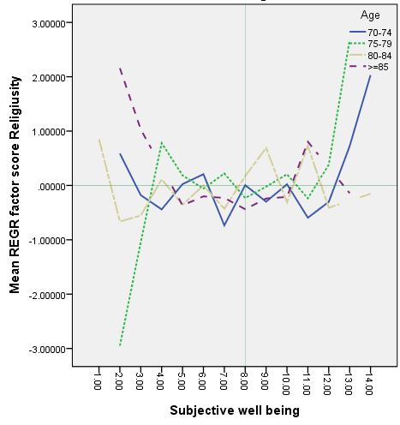  Figure 1a. | 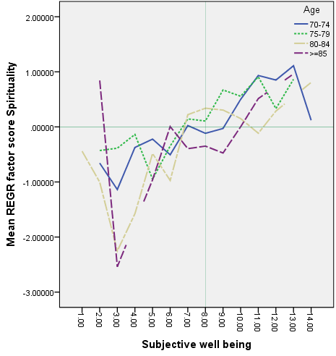  Figure 1b.
Figure 1. Religiusity and spirituality and subjective well being according age group
Note: Median subjective well being = 8; mean factor score = 0

Relationship between self religiosity and spirituality and subjective well being shows that first, sex fluctuate with increasing good well being and perceive self spirituality (figure 2b.), this means elderly perceive good physical and mental function. Second, male are more spiritual’ and have a good well being (graph increasing), figure 2b. Third, graph fluctuate at around mean of factor score religiosity. The graph relative constan in around mean of factor score (figure 2a.). Fourth, both the graph relative has the shape same model (figure 2a.).
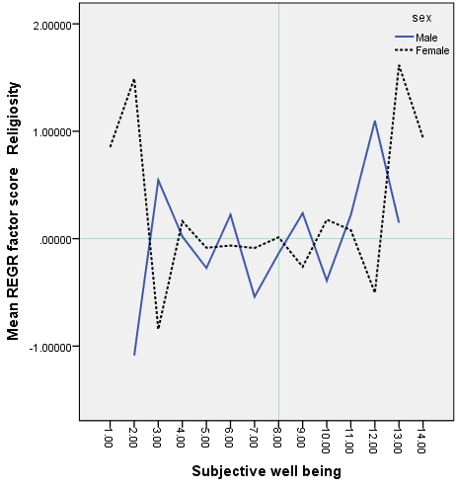  Figure 2a. | 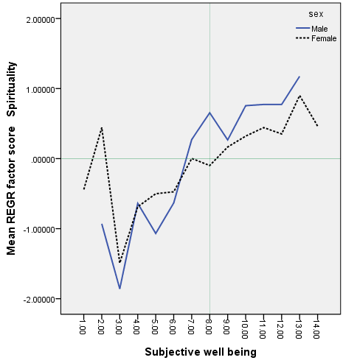  Figure 2b.
Figure 2. Religiusity and spirituality and subjective well being according sex
Note: Median subjective well being = 8; mean factor score = 0

Relationship between self religiosity and spirituality and subjective well being shows that first, marital status fluctuate with increasing good well being and perceive self spirituality (figure 3b.). Second, elderly alone are more ‘spiritual’ and have a good well being (graph increasing). Third, graph fluctuate at around mean of factor score religiosity. The graph relative constan in around mean of factor score (figure 3a.).
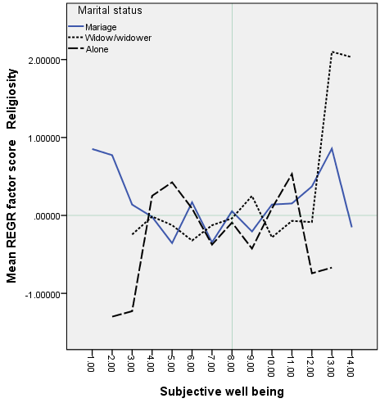  Figure 3a. | 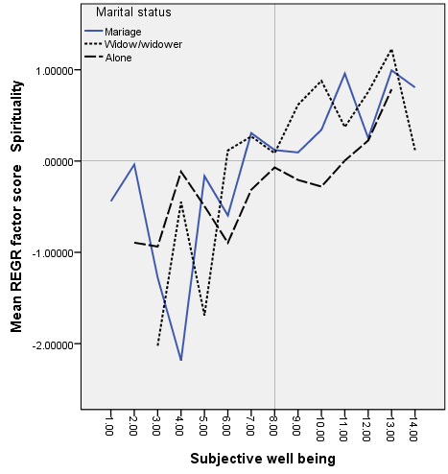  Figure 3b.
Figure 3. Religiusity and spirituality and subjective well being according marital status
Note: Median subjective well being = 8; mean factor score = 0

Relationship between self religiosity and spirituality and subjective well being shows that first, level of education fluctuate with increasing good well being and perceive self religiosity and spirituality (figure 4). Second, elderly with yunior school are more ‘spiritual’ and have a good well being (graph move increasing above value zero). Third, graph icreasing after mean of factor score spirituality (figure 4b.).
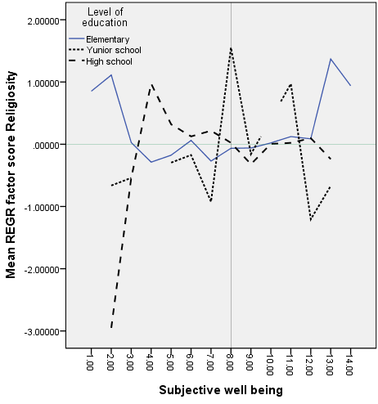  Figure 4a. | 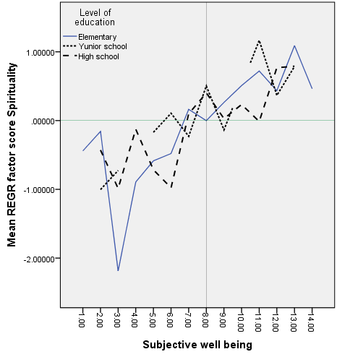  Figure 4b.
Figure 4. Religiusity and spirituality and subjective well being according level of education
Note: Median subjective well being = 8; mean factor score = 0

The influence of religius value to elderly (70-74) effect on receipt of the meaning of life. The graph of relationship between self spirituality and subjective well being shows that age 70-74 more self spiritual. Among elderly who were included the high well being but decreasing self spiritual or they were not improve themselves in seeking a meaning of life.
The influence of religiosity to elderly women’s subjective well being is rapid. This study identification that the role of spirituality in the lives of elderly woman is lower but women have good well being. The median subjective well being score female more higher than male.
The influence of religiosity to elderly alone’s subjective well being is slow. Although there is no difference subjective well being and marital status but the influence of spirituality and subjective well being to elderly who live alone is good.
Religion is an element of human life. Religion is not affected by the characteristics of the individual. Religion is the foundation of one's life. Because it is the foundation of human life then relatively constant or stable at around zero. Although the religious life one can go up and down and the evidence chart also shows that the relationship of religion in one's life fluctuate around zero.
Relationship with yourself as the private domain is is related to the values of life (spiritual). In an effort to make sense of life, the individual needs to be aware of and respond to a situation, event, and the environment by doing a fabrication of the individual. This situation seems to be influenced by individual characteristics such as sex, traveling in the life of the second age, experience marital status, and level of education.

- CONCLUSION
- According to the results of exploration the graph showed that religiosity value in live of elderly relative constan in around mean factor score. Subjective well being and self spirituality show a pattern that incresing showed elderly have a views about the meaning of life. Elderly’s perception of meaning of life depends on the resources, knowledge, and experience in which individuals live.
- Elderly’s religios commitment influence on cultural setting and where most of them are moslem. Exploring how religiosity into subjective well being of elderly living are clear.
- Elderly in their marital status are affected by the degree of subjective well being. The exploration indicate that it may be depend on elderly make life satisfaction judgments.
- Elderly level of subjective well being are widely varied.

ACKNOWLEDGEMENTS
The authors are grateful to responden for its participation and support of research.

REFERENCES
- Badan Pusat Statistik Propinsi Jawa Timur, “Menuju Era Baru Kependudukan Propinsi Jawa Timur Analisis Profil Kependudukan Hasil Sensus Penduduk 2010,” Surabaya, Badan Pusat Statistik, 2011.
- United Nations Population Division, “World Population Ageing: 1950-2050,” New York: United Nations Publications, 2002.
- Badan Pusat Statistik Propinsi Jawa Timur, “Jawa Timur dalam Angka 2013,” Surabaya, Badan Pusat Statistik, 2013a.
- Badan Pusat Statistik Propinsi Jawa Timur, “Hasil Survei Sosial Ekonomi Nasional Tahun 2012 Provinsi Jawa Timur,” Surabaya, Badan Pusat Statistik, 2013b.
- Badan Pusat Statistik Propinsi Jawa Timur, “Keadaan Angkatan Kerja di Jawa Timur Tahun 2012 Provinsi Jawa Timur,” Surabaya, Badan Pusat Statistik, 2013c.
- Hugo, G.;, “Ageing in Indonesia: A Neglected Area of Policy Concern In D.R. Phillips (Ed.), Ageing in East and South-East Asia, pp. 207–230, London: Edward, 1992.
- Kaneda, T.; Zimmer, Z.;, “Education, Gender, and Functional Transitions Among Indonesia Elderly.” Journal Cross Culture Gerontology, 22, doi: 10.1007/s10823-007-9041-7, pp. 303-322, 2007.
- WHO, “Global Health and Aging, National Institute on Aging National Institutes of Health,” U.S. Department of Health and Human Services, Available at http://www.who.int/ageing/publications/global_health.pdf, 2011.
- Dinas Kesehatan Propinsi Jawa Timur, “Profil Kesehatan Propinsi Jawa Timur 2011,” Surabaya, Dinas Kesehatan Propinsi, 2012.
- Dinas Kesehatan Propinsi Jawa Timur, “Profil Kesehatan Propinsi Jawa Timur 2012,” Surabaya, Dinas Kesehatan Propinsi, 2013.
- Hunter, S.T.;, “Can Islam and Modernity be Reconciled?,” Insight Turkey, Vol. 11, No. 3, pp. 1-12, 2009.
- Young, C.; Koopsen, C.;, “Spiritualitas, Kesehatan, dan Penyembuhan,” Medan, Bina Media Perintis, 2007.
- White, S.C.;, “Beyond the Paradox: Religion, Family and Modernity in Contemporary Bangladesh,” Modern Asian Studies 46, 5, doi: 10.1017/S0026749X12000133, pp. 1429–1458, 2012.
- Kodzi, I.A.; Gyimah, S.O.; Emina, J.B.; Ezeh, A.C.;, “Understanding Ageing in Sub-Saharan Africa: Exploring the Contributions of Religious and Secular Social Involvement to Life Satisfaction,” Aging & Society, 31, doi: 10.1017/S0144686X10001005, pp. 455-474, 2011.
- Westgate, C.E.;, “Spiritual Wellness and Depression,” Journal of Counseling and Development, JCD, September/October, 75, 1, ABI/INFORM Complete, pp. 26-35, 1996.
- Lim, C.; Putnam, R.D.;, “Religion, Social Networks, and Life Satisfaction,” American Sociological Review, December, 75, 6, ProQuest, pp. 914-933, 2010.
- Neill, C.M.; Kahn, A.S.;, “The Role of Personal Spirituality and Religious Social Activity on The Life Satisfaction of Older Widowed Women,” Sex Roles, February, 40, 3/4, ProQuest Sociology, pp. 319-329, 1999.
- Williams, M.;, “Spirituality of The Elderly,” AARN, 47, pp. 25-27, 1991.
- Sastre, M.T.M.;, “Lay Conceptions of Well Being and Rules Used in Well Being Judgments among Young, Middle Aged, and Elderly Adults,” Social Indicators Research, June 47, 2, ProQuest, pp. 203-231, 1999.
- Diener, E.;, “A Value Based Index for Measuring National Quality of Life,” Social Indicators Research, 36, pp. 107-127, 1995.
- Inglehart, R.;, “Culture Shift in Advanced Industrial Society,” Princeton University Press, Princeton, New Jersey, 1990.
- Maton, K.I.; E.A. Wells, “Religion as A Community Resource for Well Being: Prevention, Healing, and Empowerment Pathways,” Journal of Social Issues, 51, pp. 177-193, 1995.
- Lee, G.R.; K. Seccombe; C.L. Shehan, “Marital Status and Personal Happiness: An Analysis of Trend Data,” Journal of Marriage and The Family, 53, pp. 839-844, 1991.
- Costa, P.T.; R.R. McCrae; “Personality as a Lifelong Dterminant of Well Being, Emotion in Adult Development,” Sage, Beverly Hills, California, pp. 141-156, 1984.
- Lawton, M.P.;, “The Philadelphia Geriatric Center Morale Scale: A Revision,” Journal of Gerontology, 30, 1, pp. 85-89, 1975.
- Zullig, K.J.; Ward, R.M.; Horn, T.;, “The Association Between Perceived spirituality, Religiosity, and Life Satisfaction: The Mediating Role of Self-Rated Health,” Social Indicators Research, 79, doi: 10.1007/s11205-005-4127-5, pp. 255-274, 2006.
- Jang, S.N.; Choi, Y.J.; Kim, D,H.;, “Association of Socioeconomic Status With Successful Ageing: Differences in The Components of Successful Ageing,” J.Biosoc.Sci, 41, doi: 10.1017/S0021932008003052, pp. 207-219, 2009.

BIIOGRAPHY OF AUTHORS

First author’s photo(3x4cm) | Full Name: Rachmah Indawati  Rank: Lektor Kepala  Research interest: Elderly people  Research experience: 10  Academic publications: 6  Books: 1
Second author’s photo(3x4cm) | Full Name: Kuntoro  Rank: Profesor  Research interest: Elderly people  Research experience: 15  Academic publications: 5  Books: 5
Thirth author’s photo(3x4cm) | Full Name: Hari Basuki Notobroto  Rank: Lektor Kepala  Research interest: Elderly people  Research experience: 20  Academic publications: 15  Books: 5
Fourth author’s photo(3x4cm) | Full Name: Mochammad Bagus Qomaruddin  Rank: Lektor Kepala  Research interest: Gerontology social  Research experience: 13  Academic publications: 10  Books: 2

