Dengue Fever (DF) vulnerability assessment and mapping in Gorontalo Regency using multi-criteria analysis (AHP) model and geoinformation techniques

Ririn Pakaya¹, Muhammad Ramdhan Olii², Yanti Hz. Hano ³ (10 pt)
^{1,3}Department of Public Health, Universitas Gorontalo, Gorontalo, Indonesia
Jalan A.A. Wahab No. 247, Limboto, Gorontalo
²Department of Civil Engineering, Universitas Gorontalo, Gorontalo, Indonesia
Jalan A.A. Wahab No. 247, Limboto, Gorontalo

Article Info |  | ABSTRACT (10 PT)
Article history:  Received Jun 9, 2021  Revised July 20, 2021  Accepted Sep 11, 2021 |  | One method of reducing the spread of DF is to provide a map of DF-prone locations based on spatial analysis. The primary method of preventing the spread of dengue fever (DF) is to control and monitor its vector by concentrating on specific localization areas and eliminating suitable breeding environments. Spatial analysis can detect DF clusters that are larger than expected based on the underlying data. The aim of this paper was to identify, and map areas of DF vulnerability based on several factors within Analytic Hierarchy Process (AHP) and Geographical Information Systems (GIS) framework. As a result, the AHP factor weights were evaluated and found to be acceptable as the consistency ratio of 0.079, which was 0.1. Population density, distance to the road, radius of health facilities were discovered to be the most influential factors to DF vulnaribility. Gorontalo Regency is dominated by low vulnerability classes with an area of 139,493.5 ha or 65.08% of the total area. The GIS-AHP process could be used to assess transmissible DF vulnerability zonation, which would aid in improving surveillance strategies for DF and other vector-borne diseases in order to encourage prevention and control actions.
Keywords:
Dengue Fever (DF)
Spatial Analysis
Analytic Hierarchy Process (AHP)
Geographical Information Systems (GIS)
Vulnaribility
 |  | This is an open access article under the CC BY-SA license.
Corresponding Author:
Ririn Pakaya,
Department of Public Health,
Universitas Gorontalo,
Jalan A.A. Wahab No. 247, Limboto, Gorontalo, Indonesia.
Email: ririn.pakaya@mail.ugm.ac.id

- INTRODUCTION
Dengue fever (DF) is a mosquito-borne viral disease that has spread rapidly in all WHO regions in recent years. The dengue virus is spread to humans via the bites of infected female mosquitos, primarily Aedes aegypti and, to a lesser extent, Aedes albopictus. These mosquitos also transmit the chikungunya, yellow fever, and Zika viruses. DF is found throughout the tropics, with local variations in risk caused by factors such as rainfall, temperature, relative humidity, and unplanned rapid urbanization.
DF has become increasingly common in recent decades all over the world. Because the vast majority of dengue cases are asymptomatic or mild and self-managed, the true number of DF is likely to be underestimated. A large number of cases are also misdiagnosed as other febrile illnesses [1]. According to one modeling estimate, 390 million dengue virus infections occur each year (95 percent credible interval 284–528 million), with 96 million (67–136 million) presenting clinically (with any severity of disease) [2]. According to another study on the prevalence of dengue, 3.9 billion people are at risk of infection with dengue viruses. Despite the fact that there is a risk of infection in 129 countries [3] Asia bears 70% of the actual burden [2]. Over the last two decades, the number of DF reported to WHO has increased more than eightfold, from 505,430 cases in 2000 to over 2.4 million in 2010, and 5.2 million in 2019. Between 2000 and 2015, the number of reported deaths increased from 960 to 4032. Dengue fever struck several countries in 2020, with an increase in cases in Bangladesh, Brazil, Cook Islands, Ecuador, India, Indonesia, Maldives, Mauritania, Mayotte (Fr), Nepal, Singapore, Sri Lanka, Sudan, Thailand, Timor-Leste, and Yemen. Dengue fever continues to afflict Brazil, the Cook Islands, Colombia, Fiji, Kenya, Paraguay, Peru, and Reunion Island in 2021.
The use of spatial analysis in geographical information systems (GIS) for health purposes is quickly becoming one of the most important techniques for identifying spatial associations, and it is being adopted by a growing number of researchers worldwide [4]–[12]. One way to reduce the spread of DF is to provide a map of locations that are prone to DF by spatial analysis. The primary method of preventing the spread of DF is to control and monitor its vector by focusing on specific localization areas and destroying suitable breeding environments [13]. Spatial analysis can identify DF clusters that are larger than what would be expected based on the underlying environmental characteristics, climatology, and demographic structure. The integration of the Analytical Hierarchy Process (AHP) method in GIS to solve public health problems has received considerable attention among researchers [7], [8], [12], [14]. Multi-criteria decision making techniques can be used to make the public health problems more explicit, rational and efficient.
B. Bhatt and Joshi (2014) revealed the importance and potential of integrating geospatial tools and the Analytical Hierarchy Process for malaria risk zones and transmission dynamics. Dom et al. (2016) study's findings provided valuable insights that could potentially improve public health initiatives. The geographical information system and spatial analytical method could be used to supplement DF and other communicable disease surveillance strategies in order to promote prevention and control actions. Ali and Ahmad (2018) demonstrated how AHP-GIS can aid in understanding the pattern and distribution of dengue outbreaks, as well as the zonation of potential risk areas. Rakotoarison et al. (2020) proved GIS integrated with AHP, with their capacity for spatially referenced data storage, data management, analysis, modeling, and mapping, is a useful tool for understanding spatial decision issues in malaria-risk areas in Madagascar. Li et al. (2017) estimated the risk of ZIKV disease transmission in Guangdong, China with AHP-GIS and found higher risk was observed in the Pearl River Delta, including Guangzhou, Shenzhen, and Nanjing.
Previously, most studies used GIS-AHP to model DF risk or vulnerability based on a number of commonly used variables, such as topography, climatology and population demographics. These variables have limitations and for this reason, we propose the use of several variables that allow interaction between humans, namely the spread of dengue fever through humans via the bites of infected female mosquitos (i.e. population density, distance to the road, radius of health facilities, radius of educational facilities, radius of office area, and land use) to define DF vulnerability zones. The buffer distance was considered due to the flight distance factors covered during the Aedes mosquito's life span [16]. Female mosquitoes have an average lifespan of 8-15 days and can fly 30-50 meters per day. This suggests that female mosquitos can travel a distance of 240 – 600 m during their lifetime [17].

- RESEARCH METHOD
2.1. Study Area
Gorontalo District is a plateau with an average elevation of 50 meters above sea level and an altitude range of 0 to 2,062 meters. Gorontalo District is geographically located between 0º28'23.22" - 0º55'45.08" North Latitude and 122º14'43.69" - 123º4'48.27" East Longitude. Gorontalo Regency has a total land area of 2,159 km². The administrative area of Gorontalo Regency in 2020 consists of 19 Districts and 205 villages, with Limboto District serving as the capital city. The largest district is Asparaga District, which covers 430.51 km² or 20.25 percent of the land area in Gorontalo Regency, while the smallest sub-district is Tilango District, which covers 5.79 km² or 0.27 percent of the total area in Gorontalo Regency. North Gorontalo Regency borders the northern part of Gorontalo Regency, Bone Bolango Regency and Gorontalo City border the eastern part, Tomini Bay borders the southern part, and Boalemo Regency borders the western part. The highest temperature in Gorontalo Regency in 2020 was 35.2ºC in October, while the lowest temperature was 18.8ºC in September. In March and June, the humidity reaches 97%, while in October, the humidity drops to 65 percent. The highest duration of exposure was in September, at 79.90%, and the lowest was 45.10%. The wettest month is December, with 27 rainy days.
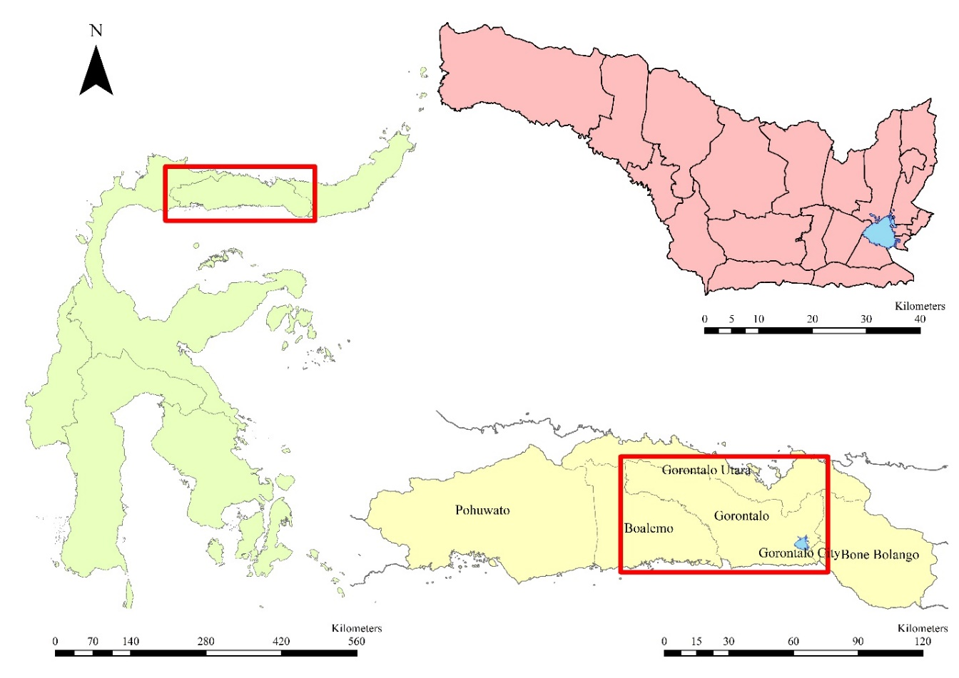
Figure 1. Location of the study area
2.2. Determination of Preliminary List of Factor
The DF conditioning factors and their relationship with the DF cases need to be assessed. In order to perform vulnerability analysis the spatial database that contains DF conditioning factors was prepared and constructed. The selection of the conditioning factors varies form one study area to another based on different characteristics of each place. The selection of factors varies from one study area to the next based on the unique characteristics of each location; it may have no influence in another region. There is no exact agreement on which factors should be used in flood susceptibility assessments. However, some of the variables are commonly used by many researchers, indicating their importance in DF vulnerability. These variables were chosen for the current study based on a field survey and information gleaned from the literature. A total of six conditioning factors were used in DHF vulnerability mapping: population density, distance to the road, radius of health facilities, radius of educational facilities, radius of office area, and land use. Table 6 shows all the conditioning factors and their characteristics. Each factor was converted into a 50 x 50 m grid spatial database, and the grid of the Gorontalo Regency was built with 857,280 grids (214,341.9 ha).
Rural areas may contribute at least as much to the dissemination of dengue fever as cities [18]. intervention measures in areas with a human population density critical for dengue virus transmission could increase the efficiency of vector control, especially since population density figures are relatively easy to obtain [18]. In this study population density devided into three classes i.e. >1,000 person/km²; 500 - 1,000 person/km²; and <500 person/km² (Table 6 and Fig. 2). Relation between DF cases with population density was DHF cases (r) is 0.891, while the Sig. (2-tailed) < 0.05, so the incidence of DHF cases is significant [19].
The Public facilities (i.e. school, road and office) cause mosquito breeding sites to increase and human interaction to increase. Chen et al. (2009) surveyed on container breeding sites of Aedes spp. and Culex spp. larvae was conducted in the campus of the University of Malaya, Kuala Lumpur and found 50.00% of the total surveyed natural containers were positive with mosquito larvae, followed by plastic containers (32.77%), plastic pails (23.81%), concrete tanks (20.00%), vases (18.75%), bottles (14.71%), cans (13.33%) and earthen plates (11.90%). To control these mosquitoes, the elimination of artificial and natural containers, as well as the modification of breeding sites in and around public facilities, should be considered [20]. Mahabis et al. (2012) stated there is a relationship between the road and the incidence of dengue. The major motorways may form major ‘barriers’ to the flying mosquitoes because the volume of traffic is greater on these roads and especially during blood feeding periods for mosquitoes (early morning and later evening) since these usually coincide with journeys to and from work. The foraging mosquitoes' flight speed allows them to succumb to the traveling velocity of vehicles at this time. In addition, the width of major roads increases the likelihood of being caught in a vehicle's "wind tunnel." Minor highways, on the other hand, typically have a lower volume of traffic and narrower widths. This general pattern is reflected in the findings, with an increase in the number of dengue cases occurring closer to minor class roads [21]. Regilme, et.al (2021) suggested that human-made landscape features such as primary roads are potential barriers to mosquito movement thereby limiting its gene flow across the road.
Harapan, et al. (2019) stated DF cases correlate by health facilities. First, this decline was associated with improved management protocols of the diseases in the Community Health Centres or hospitals. Second, this was associated with increased knowledge and awareness both of community members and healthcare providers, and better diagnostics including more sensitive and specific diagnostic tests [23]
Dengue disease transmission is influenced by complex interactions between vector, host, and virus. Land use, such as water bodies or specific agricultural practices, has been identified as a potential risk factor for dengue because they provide suitable habitat for the vector [24]. Land use factors are an important component to consider in vector control strategic planning and implementation [24]. In this study, land use devide into water bodies (2,808 ha) , settlement (2,926 ha), plantation/agriculture (71,790), shrubs/open Area (52,307 ha), and forest (84,511 ha) (Fig. 2). The dengue incidence rate (cases per 100,000 inhabitants) was low in high vegetation cover areas, but high in low vegetation cover areas where the land surface temperature was 29 ± 2 °C [25].
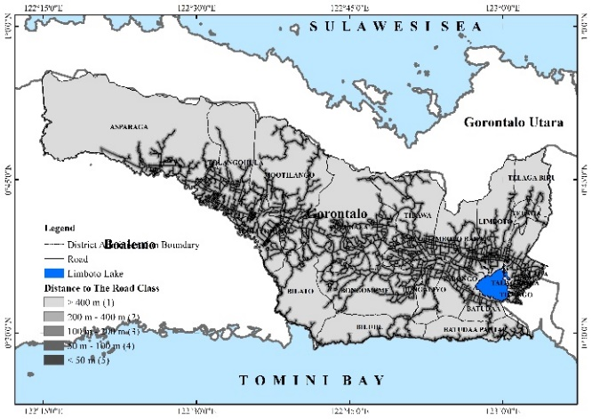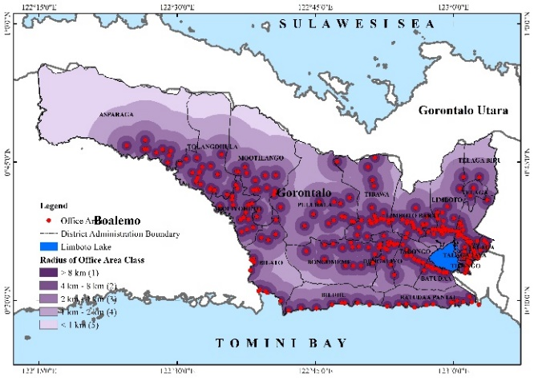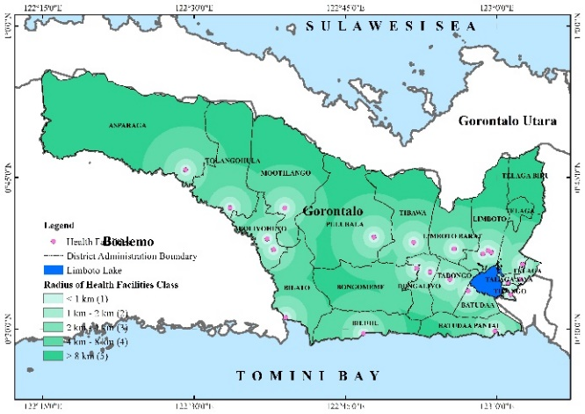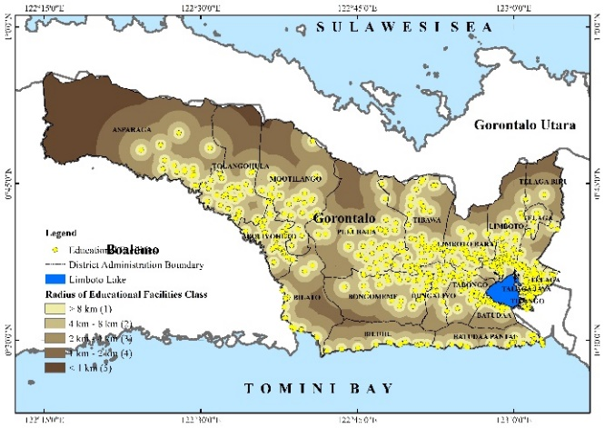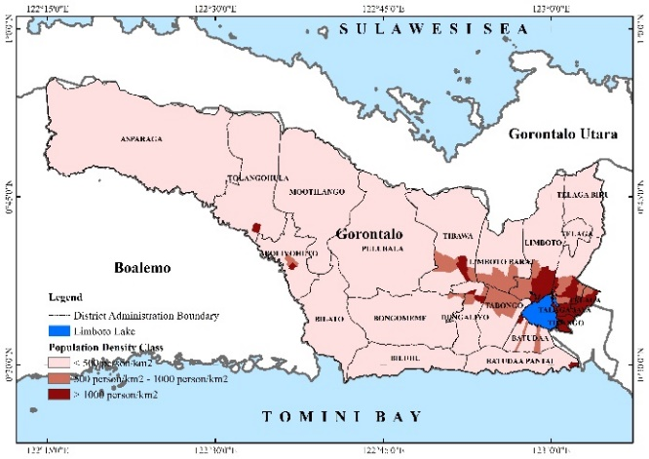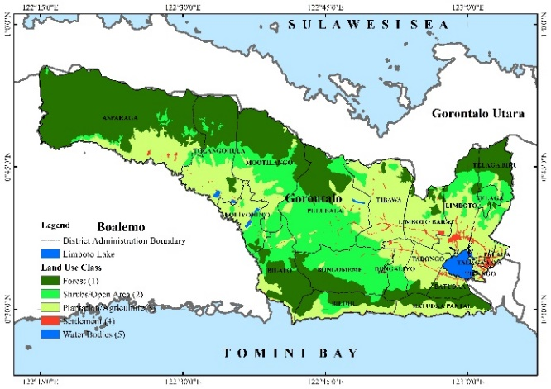
Figure 2. The factors of DHF vulnerability
2.3. Methodology
Analytical Hierarchy Process (AHP) is a mathematical problem-solving tool that gained popularity among management personnel in the late 1990s and early 2000s. Saaty (1980; 2008) developed a multicriteria decision-making technique that provides a systematic approach for assessing and integrating the effects of various factors, involving several levels of dependent or independent qualitative and quantitative data. This procedure included a variety of options in the decision and was capable of performing sensitivity analysis on the following criteria and benchmarks. Furthermore, because of the paired comparisons, it simplifies judgments and calculations. In addition, it demonstrates the compatibility and incompatibility decisions that result from multi-criteria decision making. The relative importance of the criteria is scaled from 1 to 9, with 1 indicating the least important criteria and 9 indicating the most important criteria (Table 1). The AHP procedure is as follows [26], [27]:
Step 1: Define alternatives
Step 2: Define the problem and criteria
Step 3: Establish Priority amongst criteria using pairwise comparison
Step 4: Check Consistency Ratio (CR) using Eq.1
Step 5: Get the relative weights
(1)
where CI is consistency Index, RI is a random index indicating the consistency of a pairwise comparison matrix generated at random (See Table 2), n is number of criteria and λ_{max} is the maximum eigenvalue of the comparison matrix,. When the CR value is less than 10%, the judgment is consistent; when it exceeds 10%, the assessments may need to be revised.
Tabel 1. The relative importance of the criteria [26], [27]
Intensity | Definition | Explanation
1 | Equal importance | Two elements contribute equally to the goal.
3 | Moderate importance | Experience and judgement favor one element slightly more than another
5 | Strong importance | Experience and judgement strongly favor one element over another
7 | Very strong importance | One element is strongly favored over another, and its dominance is demonstrated in practice
9 | Extreme importance | The evidence in favor of one element over another is of the highest order of confirmation
2,4,6,8 | Can be used to express intermediate values

Table 2. Random Index (RI) Value
n | 1 | 2 | 3 | 4 | 5 | 6 | 7 | 8 | 9 | 10
RI | 0.00 | 0.00 | 0.58 | 0.90 | 1.12 | 1.24 | 1.32 | 1.41 | 1.45 | 1.49

- RESULTS AND DISCUSSIONS

3.1. Results
In Table 3, the criteria listed on the left are one by one compared with each criterion listed on top depending on which one is more important with respect to the goal (determination of DF vulnerability areas) The eigenvalue method was used to calculate the weights for each matrix. To obtain the overall priorities, we used the synthesis procedure, which required multiplying each ranking by the priority of its criterion and sub criterion and adding the resulting weights for each alternative to obtain its final priority. The weight assign to each criterion and sub criterion to determine DF vulnerability are in Tables 4 and 6.

Table 3. Pair-wise comparison matrix
DHF Vulnerability Class | PD | DR | REF | ROA | RHF | LU
PD | 1.00 | 2.00 | 3.00 | 3.00 | 3.00 | 7.00
DR | 0.50 | 1.00 | 4.00 | 4.00 | 0.33 | 5.00
REF | 0.33 | 0.25 | 1.00 | 2.00 | 0.33 | 3.00
ROA | 0.33 | 0.25 | 0.50 | 1.00 | 0.33 | 3.00
RHF | 0.33 | 3.00 | 3.00 | 3.00 | 1.00 | 5.00
LU | 0.14 | 0.20 | 0.33 | 0.33 | 0.20 | 1.00
Note: PD is Population Density; DR is Distance to The Road; REF is Radius of Educational Facilities; ROA is Radius of Office Area; RHF is Radius of Health Facilities; and LU is Land Use
Table 4. Weight of factors
DHF Vulnerability Class | PD | DR | REF | ROA | RHF | LU | Total | Weight Vector
PD | 0.38 | 0.30 | 0.25 | 0.23 | 0.58 | 0.29 | 2.02 | 0.34
DR | 0.19 | 0.15 | 0.34 | 0.30 | 0.06 | 0.21 | 1.25 | 0.21
REF | 0.13 | 0.04 | 0.08 | 0.15 | 0.06 | 0.13 | 0.59 | 0.10
ROA | 0.13 | 0.04 | 0.04 | 0.08 | 0.06 | 0.13 | 0.47 | 0.08
RHF | 0.13 | 0.45 | 0.25 | 0.23 | 0.19 | 0.21 | 1.45 | 0.24
LU | 0.05 | 0.03 | 0.03 | 0.03 | 0.04 | 0.04 | 0.22 | 0.04
Total | 1.00 | 1.00 | 1.00 | 1.00 | 1.00 | 1.00 | 6.00 | 1.00
Note: PD is Population Density; DR is Distance to The Road; REF is Radius of Educational Facilities; ROA is Radius of Office Area; RHF is Radius of Health Facilities; and LU is Land Use

Table 5. Summary of values
Parameter | Values
λ_{max} | 6.49
n | 6
RI | 1.24
CI | 0.1
CR | 0.079

The DF vulnerability model was constructed based on the conditioning factors that have been reclassified using the weights achieved from AHP method. The coefficients and significances were measured using AHP and are listed in Table 4 or Table 5. Among the conditioning factors, population density showed the highest weight (0.34) as it had the most significant impact on DF vulnerability and the lowest weight (0.04) was assigned to the land use. In order to produce probability map the values obtained from DF vulnerability were transferred to the ArcGIS 10.8 software and Eq (2) was applied to the conditioning factors.
(2)
where DFV is Dengue Fever Vulnerability Score, PD is Population Density Score; DR is Distance to The Road Score; REF is Radius of Educational Facilities Score; ROA is Radius of Office Area Score; RHF is Radius of Health Facilities Score; and LU is Land Use Score.
Table 6. Weight of criteria and sub-criteria
No. | Criteria | Sub-Criteria | Criteria Weight (W) | Score (S) | W x S
1 | Population density | >1,000 person/km² | 0.34 | 3 | 1.012
 |  | 500 - 1,000 person/km² |  | 2 | 0.675
 |  | <500 person/km² |  | 1 | 0.337
2. | Distance to the road | <50 m | 0.21 | 5 | 1.041
 |  | 50 m - 100 m |  | 4 | 0.833
 |  | 100 m - 200 m |  | 3 | 0.624
 |  | 200 m - 400 m |  | 2 | 0.416
 |  | > 400 m |  | 1 | 0.208
3. | Radius of educational facilities | < 1 km | 0.10 | 5 | 0.489
 |  | 1 km - 2 km |  | 4 | 0.391
 |  | 2 km - 4 km |  | 3 | 0.294
 |  | 4 km - 8 km |  | 2 | 0.196
 |  | > 8 km |  | 1 | 0.098
4. | Radius of office area | < 1 km | 0.08 | 5 | 0.391
 |  | 1 km - 2 km |  | 4 | 0.313
 |  | 2 km - 4 km |  | 3 | 0.235
 |  | 4 km - 8 km |  | 2 | 0.157
 |  | > 8 km |  | 1 | 0.078
5. | Radius of health facilities | > 8 km | 0.24 | 5 | 1.211
 |  | 4 km - 8 km |  | 4 | 0.969
 |  | 2 km - 4 km |  | 3 | 0.727
 |  | 1 km - 2 km |  | 2 | 0.484
 |  | < 1 km |  | 1 | 0.242
6. | Land use | Water Bodies | 0.04 | 5 | 1.211
 |  | Settlement |  | 4 | 0.969
 |  | Plantation/Agriculture |  | 3 | 0.727
 |  | Shrubs/Open Area |  | 2 | 0.484
 |  | Forest |  | 1 | 0.242

As shown in Fig. 3, the DF vulnerability map produced by combining population density, distance to the road, radius of health facilities, radius of educational facilities, radius of office area, and land use highlights five classes (very low to very high). In the next step, from Eq. (1), probability DF Vulnerability was calculated which has the range from <2.036 to >4.525. This index represents the predicted DF vulnerability for each grid in the presence of a given set of conditioning factors. DF Vulnerability map was prepared through the popular method adopted in the literature by dividing the vulnerability map into specific number of classes. The range of values of DF vulnerability map was classified using quantile method into five categories of very low (<2.036), low (2.036 – 2.866), moderate (2.866 – 3.696), high (3.696 – 4.525) and very high (>4.525). The DF vulnerability map produced using the ensemble DFV model (Eq. 2) is shown in Fig. 3.
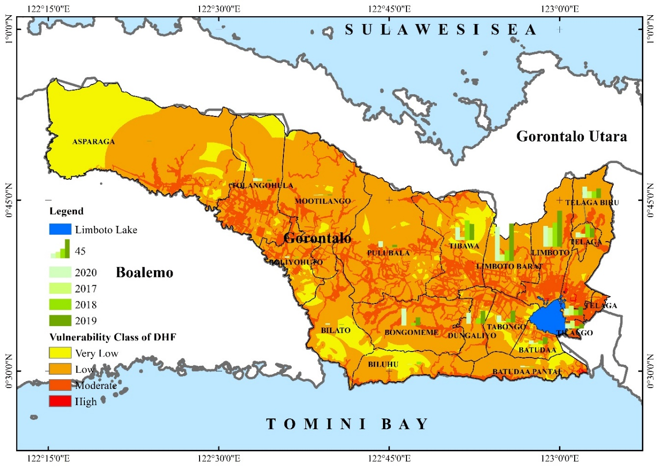
Figure 3. Distribution of DHF vulnerability class

The very low and low classes account for 16.06%and 65.08% of the Gorontalo Regency, respectively. It is primarily areas with forest and plantation, with a lower population density. The proportions of areas covered by the moderate and high classes of vulnerability are 17.71% and 0.08 percent, respectively. According to the analysis, all of these areas of moderate and high vulnerability are dominated by their proximity to public facilities and roads, distance from health facilities, high population density, and settlement within the Gorontalo Regency.
Table 8. Distribution of DHF vulnerability class
DHF Vulnerability Class | Range Weight | Area  (Ha) | %  Area
Very Low | <2.036 | 34,425.6 | 16.06
Low | 2.036 – 2.866 | 139,493.5 | 65.08
Moderate | 2.866 – 3.696 | 37,963.8 | 17.71
High | 3.696 – 4.525 | 163.5 | 0.08
Very High | >4.525 | 0.0 | 0
Limboto Lake |  | 2,295.5 | 1.07
Total |  | 214,341.9 | 100

3.2. Discussions
Many studies have found that environmental factors play a role in dengue transmission and distribution. Environmental parameters can have an impact on the transmission pattern of DF in both direct and indirect ways. A direct impact can be defined as changes in environmental conditions that influence the trend of dengue transmission and distribution pattern. Human population dynamics and their effects on exposure vulnerability and other landscape features are two examples of environmental parameters that have an indirect impact on the trend of dengue transmission and distribution [13]. Based on the combination of multiple variables using AHP, the overall model of DF risk in Gorontalo Regency shows that the vulnerability area is mostly confined to areas with a high population density. This finding is consistent with the findings of several studies, which found that DF risk cases increased in areas with a high population density [28], [29]. The higher the population of an area, the greater the potential for female mosquitoes to fly and bite between humans and each other. They live for an average of 8-15 days and can fly 30-50 meters per day, covering a distance of 240 – 600 m in their lifetime (Bohra and Andrianasolo 2001). The Aedes aegypti mosquito lives in urban areas and primarily breeds in man-made containers.
The proximity of mosquito vector breeding sites to human habitation is a significant vulnerability factor for dengue and other diseases transmitted by the Aedes mosquito. At the moment, the primary method for controlling or preventing dengue virus transmission is to combat mosquito vectors [30]. Therefore, the variables related to the potential location for mosquitoes to breed are public facilities which of course have containers (i.e. road, educational facilities, and office area). The influence of population density variables, distance to highways, educational facilities radius, office area radius, and land use on the spread of dengue fever in two ways, namely prevention of mosquito breeding (i.e. (1) using environmental management and modification to prevent mosquitos from accessing egg-laying habitats; (2) removing artificial man-made habitats that can hold water and properly disposing of solid waste; (3) weekly covering, emptying, and cleaning of domestic water storage containers; (4) applying appropriate insecticides to outdoor water storage containers) and personal protection from mosquito bite (i.e. (1) personal household protection measures, such as window screens, repellents, insecticide-treated materials, coils, and vaporizers, are used. Because the primary mosquito vectors bite throughout the day, these precautions must be taken both inside and outside the home (e.g., at work/school); (2) It is recommended that you wear clothing that reduces your skin's exposure to mosquitoes [30].
The factor of distant health facilities has a considerable influence on this study, which is 24%. This factor can be overcome in three ways, namely community engagement (i.e. (1) educating the public about the dangers of mosquito-borne diseases; (2) engaging the community in order to increase participation and mobilization for long-term vector control); reactive vector control (i.e. health authorities may use emergency vector control measures such as space spraying insecticides during outbreaks); and active mosquito and virus surveillance (i.e. (1) to determine the effectiveness of control interventions, active monitoring and surveillance of vector abundance and species composition should be carried out; (2) active screening of sentinel mosquito collections will be used to track the prevalence of virus in the mosquito population in the future) [30]. Because of advances in geographic information systems (GIS) technology, the ability to accurately predict local and regional DF outbreaks has rapidly improved. This has led to a better understanding of the interaction between the spatial and temporal distributions of DF, as well as increased research interest in epidemic prediction modeling.

Ethics Approval
This research does not involve humans in its research, but this research has an ethical license issued by the Kadiri University Research Institute with Registration Number 004/25/V/EC/KEP/UNIK/2021.

- CONCLUSION
The spatial relationship between cases and disease can be displayed and modeled using GIS-AHP and spatial temporal modeling techniques. Because of the powerful application of GIS technology to visualise the temporal and spatial distributions based on ecological determinants, spatial temporal modeling can help us understand the distribution of dengue outbreaks in space and time. AHP assists the decision maker in making the correct decision by indicating the importance of the decision, and inconsistency will appear if the decision is incorrect. The GIS-AHP used in this study demonstrates that all selected decision criteria with varying weights satisfy the Consistency Ratio and are thus considered acceptable and consistent for dengue vulnerability mapping in Gorontalo Regency. There are no medically prescribed treatments for dengue. The only treatment is to locate an appropriate breeding site i.e. vectors and its destruction. As a result, the current study focuses on some of the closely related environmental factors that are responsible for DF outbreaks, as well as GIS-based spatial analysis for vulnerability zonation. Gorontalo Regency dominated low class vulnerability, according to the results. Similarly to the current study, the GIS-AHP process could be used to assess transmissible disease vulnerability zonation, which aids in improving surveillance stratagems for DF and other vector-borne diseases to encourage prevention and control actions.

ACKNOWLEDGEMENTS
The authors would like to thank all of the organizations mentioned in the paper for providing the necessary data for the study, as well as the Ministry of Research and Higher Education of the Republic of Indonesia for providing financial support in the form of research funding.

REFERENCES
[1] J. J. Waggoner et al., “Viremia and Clinical Presentation in Nicaraguan Patients Infected With Zika Virus, Chikungunya Virus, and Dengue Virus,” Clin. Infect. Dis., vol. 63, no. 12, pp. 1584–1590, 2016, doi: 10.1093/cid/ciw589.
[2] S. Bhatt et al., “The global distribution and burden of dengue,” Nature, vol. 496, no. 7446, pp. 504–507, 2013, doi: 10.1038/nature12060.
[3] O. J. Brady et al., “Refining the Global Spatial Limits of Dengue Virus Transmission by Evidence-Based Consensus,” PLoS Negl. Trop. Dis., vol. 6, no. 8, pp. 1–15, 2012, doi: 10.1371/journal.pntd.0001760.
[4] A. Murad, “Using GIS for determining variations in health access in jeddah city, Saudi Arabia,” nternational J. Geo-Information, vol. 7, no. 7, 2018, doi: 10.3390/ijgi7070254.
[5] J. Y. Kim, S. J. Eun, and D. K. Park, “Malaria Vulnerability Map Mobile System Development Using GIS-Based Decision-Making Technique,” Mob. Inf. Syst., pp. 1–10, 2018, doi: 10.1155/2018/8436210.
[6] F. P. Ivan, B. M. Napoletano, F. Rosete-Verges, and L. Billa, “Spatial analysis and GIS in the study of COVID-19. A review,” Sci. Total Environ., vol. 739, pp. 1–10, 2020, doi: 10.1016/j.scitotenv.2020.140033.
[7] S. A. Ali and A. Ahmad, “Using analytic hierarchy process with GIS for Dengue risk mapping in Kolkata Municipal Corporation, West Bengal, India,” Spat. Inf. Res., vol. 26, no. 4, pp. 449–469, 2018, doi: 10.1007/s41324-018-0187-x.
[8] R. Zannah, S. Sulistyawati, and I. F. Dewi, “Measuring the dengue risk area using Geographic Information System: a review,” Insights Public Heal. J., vol. 1, no. 1, p. 36, 2020, doi: 10.20884/1.iphj.2020.1.1.3012.
[9] R. Pakaya, “Spatial Analysis and Environmental Factors Associated Against Case of Dengue Hemorrhagic Fever ( Dhf ) in Limboto District , Gorontalo,” in Gorontalo University, 2017, pp. 45–55.
[10] S. Saran, P. Singh, V. Kumar, and P. Chauhan, “Review of Geospatial Technology for Infectious Disease Surveillance: Use Case on COVID-19,” J. Indian Soc. Remote Sens., vol. 48, no. 8, pp. 1121–1138, 2020, doi: 10.1007/s12524-020-01140-5.
[11] D. S. S. Rejeki, N. Nurhayati, and B. Aji, “A spatiotemporal analysis of dengue hemorrhagic fever in Banyumas, Indonesia,” Int. J. Public Heal. Sci., vol. 10, no. 2, pp. 231–240, 2021, doi: 10.11591/ijphs.v10i2.20713.
[12] B. Bhatt and J. P. Joshi, “Analytical hierarchy process modeling for malaria risk zones in vadodara district, Gujarat,” Int. Arch. Photogramm. Remote Sens. Spat. Inf. Sci. - ISPRS Arch., vol. XL–8, no. 1, pp. 171–176, 2014, doi: 10.5194/isprsarchives-XL-8-171-2014.
[13] N. C. Dom, A. H. Ahmad, Z. A. Latif, and R. Ismail, “Application of geographical information system-based analytical hierarchy process as a tool for dengue risk assessment,” Asian Pacific J. Trop. Dis., vol. 6, no. 12, pp. 928–935, 2016.
[14] H. A. Rakotoarison et al., “Remote sensing and multi-criteria evaluation for malaria risk mapping to support indoor residual spraying prioritization in the central highlands of Madagascar,” Remote Sens., vol. 12, no. 10, pp. 1–22, 2020, doi: 10.3390/rs12101585.
[15] X. Li et al., “Application of the analytic hierarchy approach to the risk assessment of Zika virus disease transmission in Guangdong Province, China,” BMC Infect. Dis., vol. 17, no. 1, pp. 1–9, 2017, doi: 10.1186/s12879-016-2170-2.
[16] N. H. Schafrick, M. O. Milbrath, V. J. Berrocal, M. L. Wilson, and J. N. S. Eisenberg, “Spatial clustering of aedes aegypti related to breeding container characteristics in coastal Ecuador: Implications for dengue control,” Am. J. Trop. Med. Hyg., vol. 89, no. 4, pp. 758–765, 2013, doi: 10.4269/ajtmh.12-0485.
[17] A. Bohra and H. Andrianasolo, “Application of GIS in modeling of dengue risk based on sociocultural data: Case of Jalore, Rajasthan, India,” Dengue Bull., vol. 25, pp. 92–102, 2001.
[18] W. P. Schmidt et al., “Population density, water supply, and the risk of dengue fever in vietnam: Cohort study and spatial analysis,” PLoS Med., vol. 8, no. 8, pp. 1–10, 2011, doi: 10.1371/journal.pmed.1001082.
[19] A. Kusairi and R. Yulia, “Mapping of dengue fever distribution based on indonesian national standard cartography rules as an prevention indicator of outbreaks,” J. Pendidik. IPA Indones., vol. 9, no. 1, pp. 91–96, 2020, doi: 10.15294/jpii.v9i1.21811.
[20] C. D. Chen, H. L. Lee, S. P. Stella-Wong, K. W. Lau, and M. Sofian-Azirun, “Container survey of mosquito breeding sites in a university campus in Kuala Lumpur, Malaysia,” Dengue Bull., vol. 33, no. 1, pp. 187–193, 2009.
[21] R. S. Mahabir, D. W. Severson, and D. D. Chadee, “Impact of road networks on the distribution of dengue fever cases in Trinidad, West Indies,” Acta Trop., vol. 123, no. 3, pp. 178–183, 2012, doi: 10.1016/j.actatropica.2012.05.001.
[22] M. A. F. Regilme, T. M. Carvajal, A. Honnen, D. M. Amalin, and K. Watanabeid, “The influence of roads on the fine-scale population genetic structure of the dengue vector aedes aegypti (Linnaeus),” PLoS Negl. Trop. Dis., vol. 15, no. 2, pp. 1–14, 2021, doi: 10.1371/journal.pntd.0009139.
[23] H. Harapan, A. Michie, M. Mudatsir, R. T. Sasmono, and A. Imrie, “Epidemiology of dengue hemorrhagic fever in Indonesia: Analysis of five decades data from the National Disease Surveillance,” BMC Res. Notes, vol. 12, no. 1, pp. 4–9, 2019, doi: 10.1186/s13104-019-4379-9.
[24] Y. L. Cheong, P. J. Leitão, and T. Lakes, “Assessment of land use factors associated with dengue cases in Malaysia using boosted regression trees,” Spat. Spatiotemporal. Epidemiol., vol. 10, pp. 75–84, 2014, doi: 10.1016/j.sste.2014.05.002.
[25] R. V. Araujo et al., “São Paulo urban heat islands have a higher incidence of dengue than other urban areas,” Brazilian J. Infect. Dis., vol. 19, no. 2, pp. 146–155, 2015, doi: 10.1016/j.bjid.2014.10.004.
[26] T. L. Saaty, The Analytic Hierarchy Process. New York: McGraw Hill. International, 1980.
[27] T. L. Saaty, “Decision making with the analytic hierarchy process,” Int. J. Serv. Sci., vol. 1(1), pp. 83–98, 2008, doi: 10.1504/IJSSCI.2008.017590.
[28] Wanti et al., “Dengue hemorrhagic fever and house conditions in Kupang City, East Nusa Tenggara Province,” Kesmas, vol. 13, no. 4, pp. 177–182, 2019, doi: 10.21109/kesmas.v13i4.2701.
[29] H. Fuadzy et al., “Risk factors associated with Dengue incidence in Bandung, Indonesia: a household based case-control study,” Heal. Sci. J. Indones., vol. 11, no. 1, pp. 45–51, 2020, doi: 10.22435/hsji.v11i1.3150.
[30] WHO, Managing Epidemics, Key facts about major deadly diseases. 2018.

BIOGRAPHIES OF AUTHORS

First author’s | Ririn Pakaya, SKM,, M.P.H, completed his Masters in Public Health at the Faculty of Medicine, Universitas Gadjah Mada. Working as a Lecturer in the Public Health Sciences Study Program. As a Lecturer and Researcher, carrying out research and development tasks in the field of Environmental Health. Scientific works published in Journals including: Spatial Analysis and Environmental Factors Associated Against Case of Dengue Hemorrhagic Fever (Dhf) in Limboto District, Gorontalo (2017); Spatial – Temporal Analysis Incidence Of Dengue Hemorrhagic Fever (Dhf) Against Weather Variable In Limboto And Telaga Biru District, Gorontalo Regency Year 2012-2015(2017); The Influence of Spatial Distribution of Social Environmental Factors on the Incidence of Dengue Hemorrhagic Fever (DHF) in Limboto District (2018); Factors related to Pulmonary Tuberculosis Incident in Public Health Center of Limboto Year (2020); Spatial Distribution of Pulmonary Tuberculosis BTA Positive Associated with Weather Factors in Gorontalo City 2016-2018 (2021). Her team has received one awards recognizing the excellence and innovation of the work: Best presenter award, International Seminar in The 1st International Seminar on Developing Country, Makassar 2019.
Second author’s | Dr. Muhammad Ramdhan Olii, ST., M.Eng earned his Doctoral degree in Civil Engineering Doctoral Program – Faculty of Engineering Universitas Gadjah Mada Yogyakarta. His current research focuses on geographic information system in hydrology engineering, water resource development, disaster, land conservation and environment. His team has received many awards recognising the excellence and innovation of the work: 1) Best presenter award, National Seminar in Institut Teknologi Bandung, Bandung, 2015; 2) Best presenter award, Indonesian Association of Hydraulic Engineers Seminar Internaional, Bali, 2016; 3) Best presenter award, National Seminar in Institut Teknologi Bandung, Bandung, 2017; and 4) Best presenter award, The 1st International Conference on Innovation in Science, Health, and Technology (ICISHT), Gorontalo, 2020. His team has received several research grant from the Ministry of Research and Higher Education of the Republic of Indonesia: Doctoral Research Grant, 2016; Novice Lecturer Research Grant, 2018, Research Quality Improvement and Publications of Lecturers, 2018 & 2019; and College Excellence Basic Research Grant, 2019-2020.
Third author’s | Yanti Hz. Hano, SKM, M.Kes earned her magister degree in Public Health Faculty in Universitas Samratulangi Manado. Her Current research focus on public health administration. Evaluation of The Implementation of The Elderly Posyandu Program in the work area of The Bongomeme Health Center, Gorontalo Regency.

