Supplementary Information: Magnesium deficiency is associated with diabetic retinopathy in type 2 diabetes mellitus: A meta-analysis
Ronald Pratama Adiwinoto, Robert Dwitama Adiwinoto, Jongky Hendro Prajitno
Table S1. Quality scores of included case-control studies
Author & year | Selection |  |  |  | Comparability |  | Exposure |  |  |  | Total
 | Case definition | Case representativeness | Control definition | Control selection | Controls for most imptortant factor | Controls for additional factor | Exposure ascertainment | Blinded to case & control | Same ascertainment method | Non-respondent
Khanna D 2020 | * | * | * | - | * | * | * | - | * | * | 8/10
Naik NS 2015 | * | * | * | - | * | * | * | - | * | * | 8/10
Yossef HM 2017 | * | * | * | * | * | * | * | - | * | - | 8/10
Ganiger A 2016 | * | * | * | - | * | * | * | - | * | * | 8/10
Kundu D 2013 | * | * | * | - | - | * | * | - | * | * | 7/10
Longo-Mbenza B 2014 | * | * | * | * | * | * | * | - | * | - | 8/10
S Navin 2013 | * | * | * | - | * | * | * | - | * | * | 8/10

Table S2. Quality scores of included cross-sectional studies
Author & year | Selection |  |  |  | Comparability |  | Outcome |  |  |  | Total
 | Representativeness | Sample size | Non-respondent | Exposure ascertainment | Controls for most imptortant factor | Controls for additional factor | Blinded assessment | Record linkage | Self report | Appropriate statistical test
Dasgupta A 2012 | * | * | - | ** | * | * | - | - | - | * | 7/10
Hyassat D 2014 | * | * | - | ** | * | * | - | ** | - | * | 9/10
Kauser MM 2014 | - | * | - | ** | * | * | - | - | * | * | 7/10
Kumar P 2019 | * | * | * | ** | * | * | ** | - | - | * | 10/10
Pandey N 2019 | * | * | - | ** | - | * | - | ** | - | * | 8/10
Sharma A 2016 | * | * | * | ** | - | - | - | - | * | * | 7/10
Wahid A 2017 | - | * | * | ** | * | * | - | - | - | * | 7/10
Elhaj MSM 2016 | - | * | - | ** | * | * | - | - | - | * | 7/10
Hatwal A 1989 | - | * | - | ** | * | * | - | - | * | * | 7/10
Niranjan G 2019 | * | * | - | ** | * | * | - | (**) | - | * | 9/10

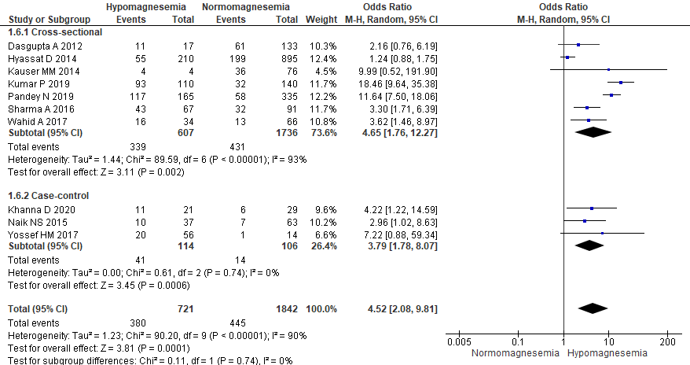
Figure S1. Subgroup analysis of pooled ORs according to study design.
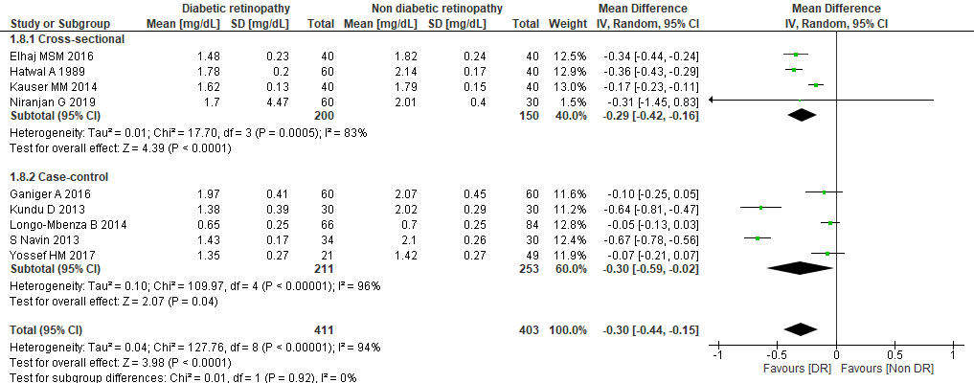
Figure S2. Subgroup analysis of pooled MDs according to study design.
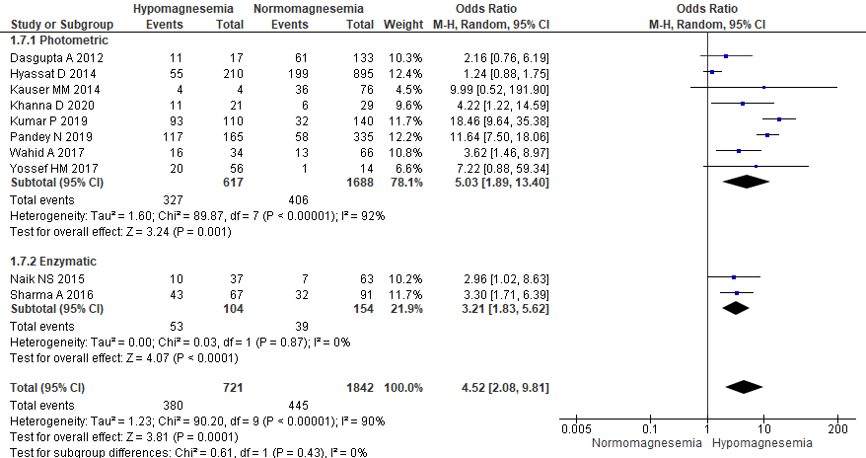
Figure S3. Subgroup analysis of pooled ORs according to serum Mg assay method.
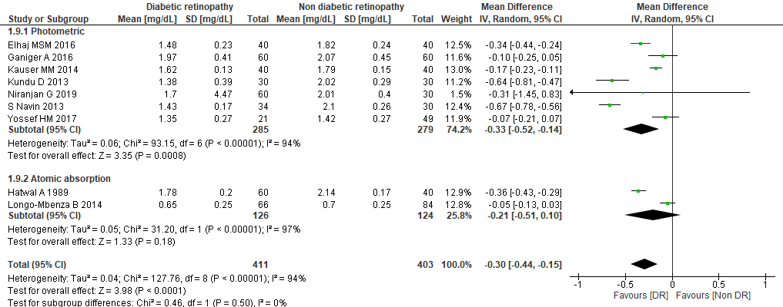
Figure S4. Subgroup analysis of pooled MDs according to serum Mg assay method.

