ETHICAL STATEMENT
Article Title: Generalized Anxiety Disorder Associated with Individual Work Performance of Indonesian Medical Personnel in Dealing with COVID-19 Outbreak

Author names:

- Eko Sujadi
- Muhammad Fadhli
- Muhd. Odha Meditamar
- Dairabi Kamil
- Ahmad Jamin
- Hengki Yandri

We hereby confirm that :
- The article we have submitted to the journal for review is original and has not been published elsewhere.
- The article is not currently being considered for publication by any other journal and will not be submitted for such review while under review by this journal.
- The article contains no libelous or other unlawful statements and does not contain any materials that violate any personal or proprietary rights of any other person or entity.

This statement is signed by all the authors to indicate agreement that the above information is true and correct:

Author’s Name: | Signature: | E-mail: | Date:
Eko Sujadi | 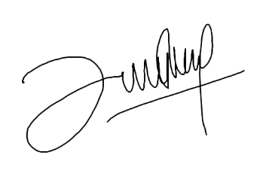 | Ekosujadi91@gmail.com | 08/15/2020
Muhammad Fadhli | 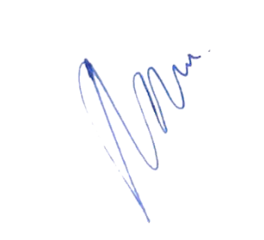 | mfadhli@unib.ac.id | 08/15/2020
Muhd. Odha Meditamar | 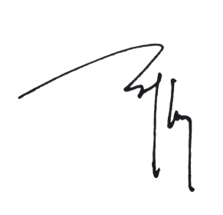 | odhameditamar@iainkerinci.ac.id | 08/15/2020
Dairabi Kamil | 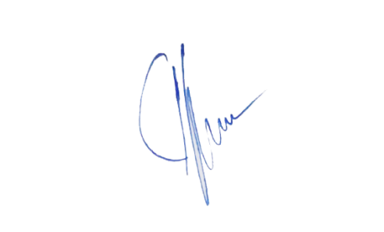 | dairabikamil@iainkerinci.ac.id | 08/15/2020
Ahmad Jamin | 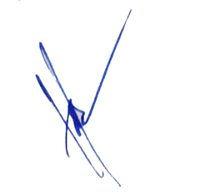 | ahmadjamin@iainkerinci.ac.id | 08/15/2020
Hengki Yandri | 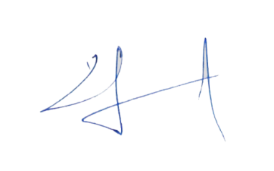 | hengkiyandri@iainkerinci.ac.id | 08/15/2020

