UJI ASUMSI REGRESI LINIER BERGANDA

- Asumsi Eksistensi (Variabel Random)

Residuals Statisticsª
 | Minimum | Maximum | Mean | Std. Deviation | N
Predicted Value | 74.8119 | 92.1182 | 82.7419 | 4.44021 | 93
Residual | -14.75034 | 11.19643 | .00000 | 5.20031 | 93
Std. Predicted Value | -1.786 | 2.112 | .000 | 1.000 | 93
Std. Residual | -2.774 | 2.106 | .000 | .978 | 93
a. Dependent Variable: Pengambilan_keputusan

- Asumsi Independensi

Model Summary
Model | R | R Square | Adjusted R Square | Durbin-Watson
1 | .656 | .430 | .390
2 | .655 | .429 | .396
3 | .649 | .422 | .395 | 1.863
Dependent Variable: Pengambilan_keputusan

- Asumsi Linieritas
ANOVAª
Model |  | Sum of Squares | df | Mean Square | F | Sig.
1 | Regression | 1849.064 | 6 | 308.177 | 10.806 | .000^{b}
1 | Residual | 2452.742 | 86 | 28.520
1 | Total | 4301.806 | 92
2 | Regression | 1845.099 | 5 | 369.020 | 13.068 | .000^{c}
2 | Residual | 2456.708 | 87 | 28.238
2 | Total | 4301.806 | 92
3 | Regression | 1813.826 | 4 | 453.457 | 16.039 | .000^{d}
3 | Residual | 2487.980 | 88 | 28.273
3 | Total | 4301.806 | 92

- Asumsi Homoscedascity
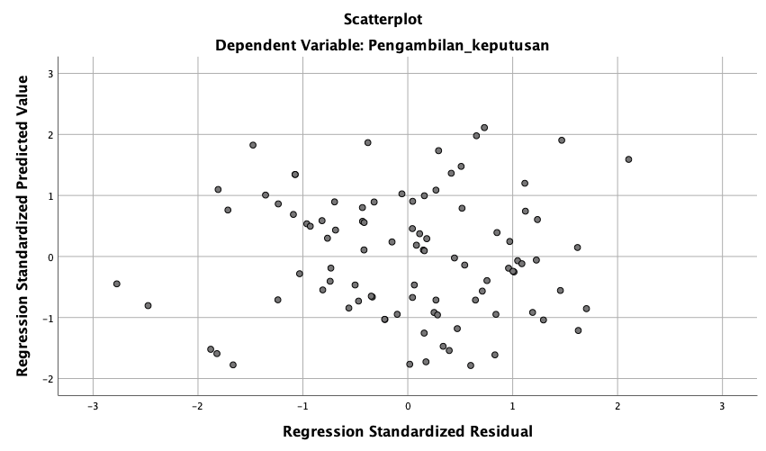
.

- Asumsi Normalitas
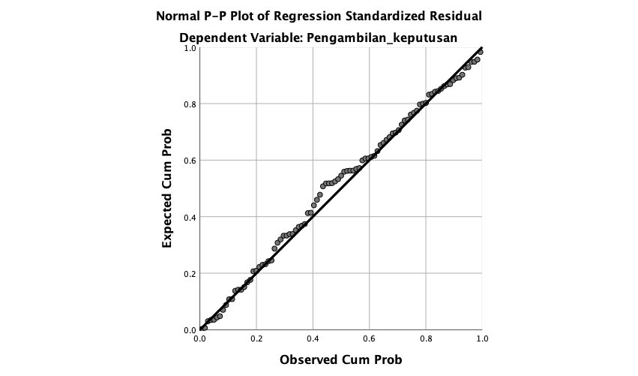

- Diagnostik Multikolinieritas

Variabel | Collinearity Statistics |  | Keterangan
Variabel | Tolerance | VIF | Keterangan
X1 (Pengetahuan) | 0.963 | 1.038 | Tidak terjadi multikolinieritas
X4 (Pengalaman kerja) | 0.967 | 1.045 | Tidak terjadi multikolinieritas
X5 (Pendidikan) | 0.960 | 1.041 | Tidak terjadi multikolinieritas
X6 (Budaya Organisasi) | 0.946 | 1.058 | Tidak terjadi multikolinieritas

